Appendix 1. Domain Analysis Table

Appendix 2. Taxonomic Diagram: Lines and Points

Appendix 3. Paradigm Table

appendix 4. schematic diagram of cultural themes

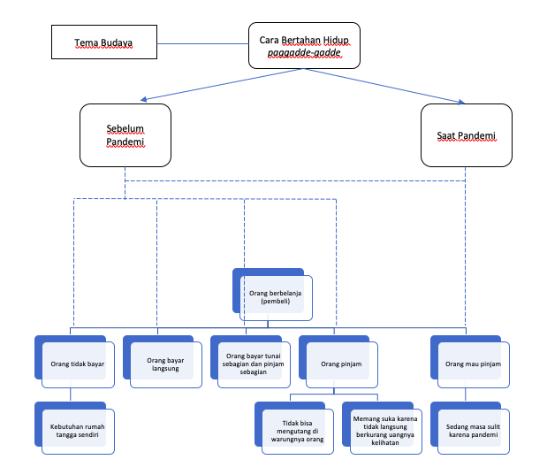

1. tema budaya | 1. a cultural theme
2. cara bertahan hidup pagadde-gadde | 2. how to survive pagadde-gadde
3. sebelum pandemi | 3. before the pandemic
4. saat pandemi | 4. during a pandemic
5. orang berbelanja (pembeli) | 5.Shopping people (buyers)
6. orang tidak bayar | 6. people don't pay
7. orang bayar langsung | 7. people pay directly
8. orang bayar tunai sebagian dan pinjam sebagian | 8. people pay some cash and borrow some
9. orang pinjam | 9. people borrow
10. orang mau pinjam | 10. people want to borrow
11. kebutuhan rumah tangga sendiri | 11. own household needs
12.tidak bisa mengutang di warung orang | 12. can not borrow at the stall
13.memang suka karena secara tidak langsung terlihat uangnya berkurang | 13. they like to make debt because it will not affect the decreasing money appearance
14. sedang masa sulit karena pandemi | 14. experience the difficulties due to pandemic

