**LAMPIRAN**

Kode Program Sistem Kontrol dan Sistem Monitoring Robot Sadetec Berbasis Internet of Things

#include<**SoftwareSerial**.h>//library for serial commnication

#define BLYNK_PRINT **Serial**

#include <ESP8266WiFi.h>

#include <BlynkSimpleEsp8266.h>

**SoftwareSerial** abc (13,15); //defie Rx-Tx pins,

int sensor = 12;

// You should get Auth Token in the Blynk App.

// Go to the Project Settings (nut icon).

char auth[] = "DFps8B_OmK5g3PfFNwJGnZpt6JMAQr8p";

// Your WiFi credentials.

// Set password to "" for open networks.

char ssid[] = "HAFAFA";

char pass[] = "14212515";

int value;

int x;

int count;

int startCount;

**WidgetLCD** lcd(V4);

void setup() {

 // put your setup code here, to run once:

 abc.begin(9600);

**Serial**.begin(115200);

**Blynk**.begin(auth, ssid, pass);

 pinMode(sensor,INPUT);

}

void loop() {

**Blynk**.run();

  lcd.print(1,0,"Jumlah Antrian:");

 lcd.print(8,1,x);

 int c= digitalRead(sensor);

 if(c==0)//kondisi sensor mendeteksi customer

 {

     count=x;

 }

 else if (c==1)

 {

   x=count+1; //counter pelanggar

   //delay(300);

 }

}

BLYNK_WRITE(V0)

{

 value = param.asInt();

  if(value==1)

 {

   abc.write(12);

 }

 else

 {

   abc.write(0);

 }

}

BLYNK_WRITE(V1)

{

 value = param.asInt();

  if(value==1)

 {

   abc.write(14);

 }

 else

 {

   abc.write(0);

 }

}

BLYNK_WRITE(V2)

{

 value = param.asInt();

  if(value==1)

 {

   abc.write(16);

 }

 else

 {

   abc.write(0);

 }

}

BLYNK_WRITE(V3)

{

 value = param.asInt();

  if(value==1)

 {

   abc.write(18);

 }

 else

 {

   abc.write(0);

 }

}

BLYNK_WRITE(V5)

{

  startCount = param.asInt();

}

Implementasi Sistem Kontrol dan Sistem Monitoring Robot Sadetec di Aplikasi Blynk

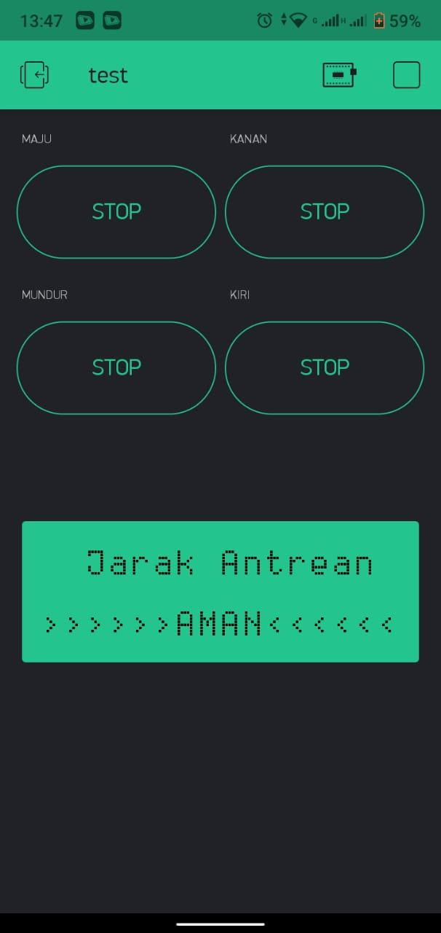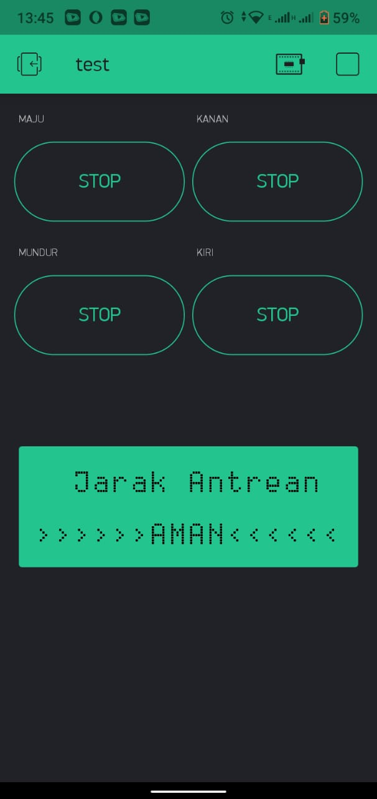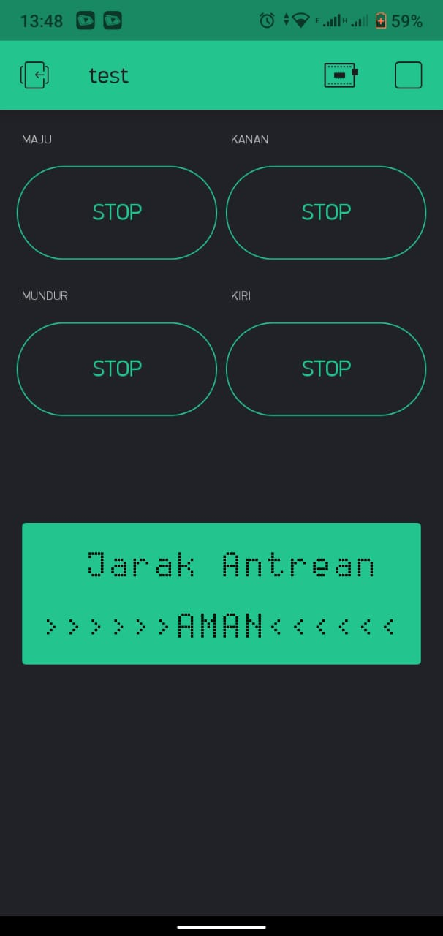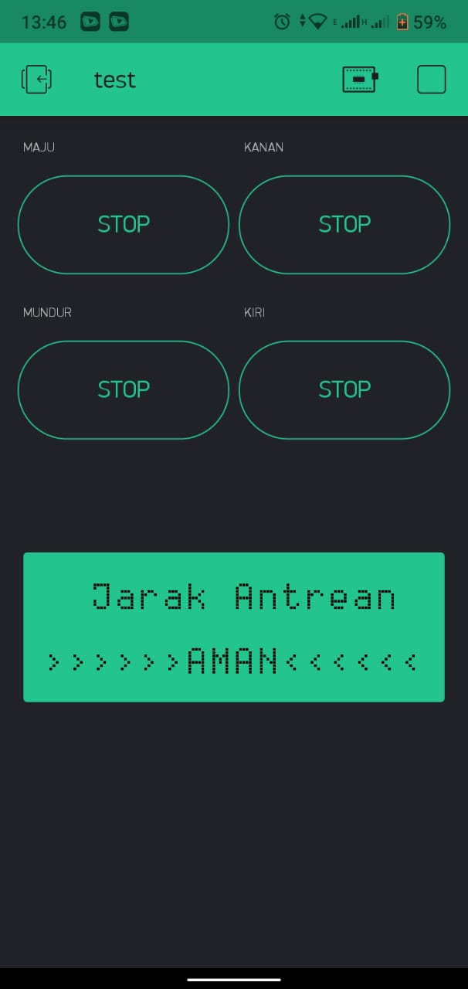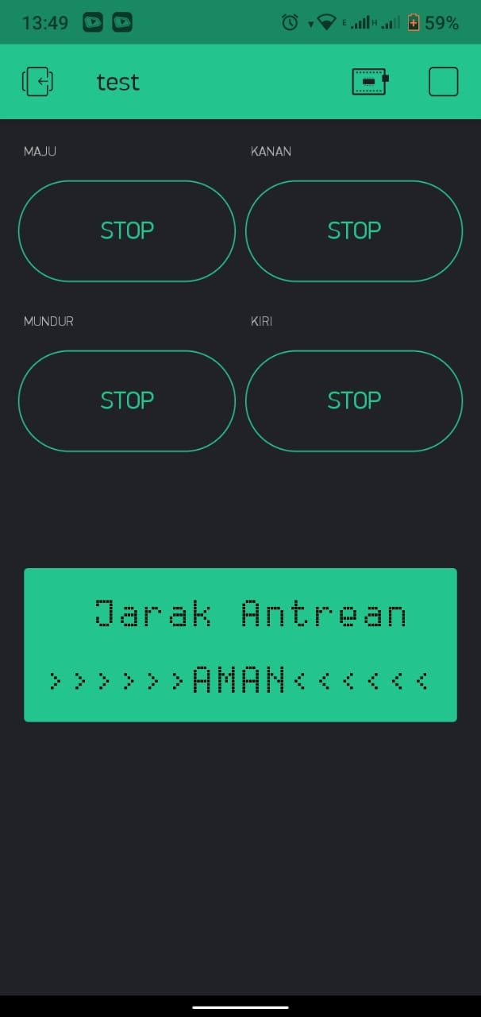

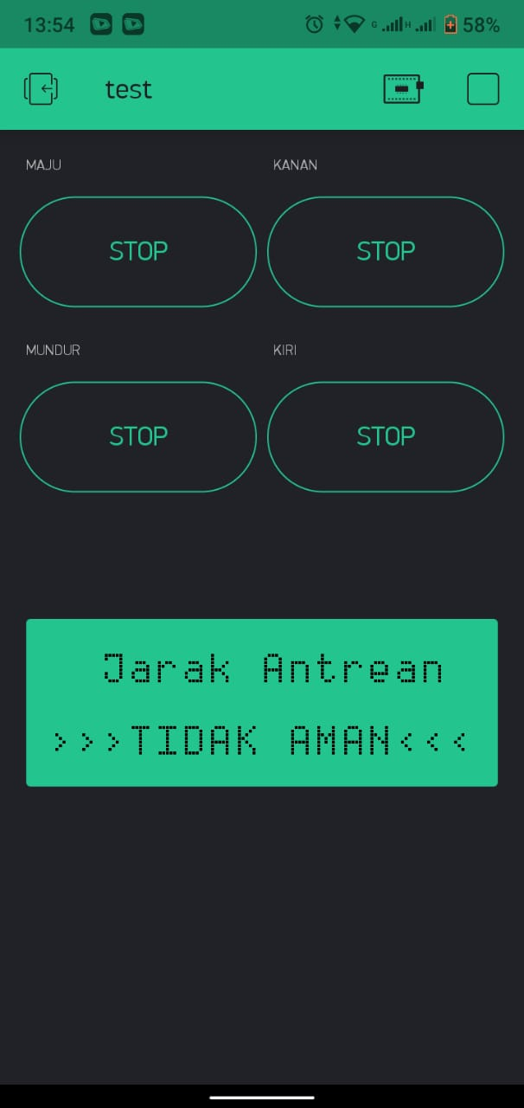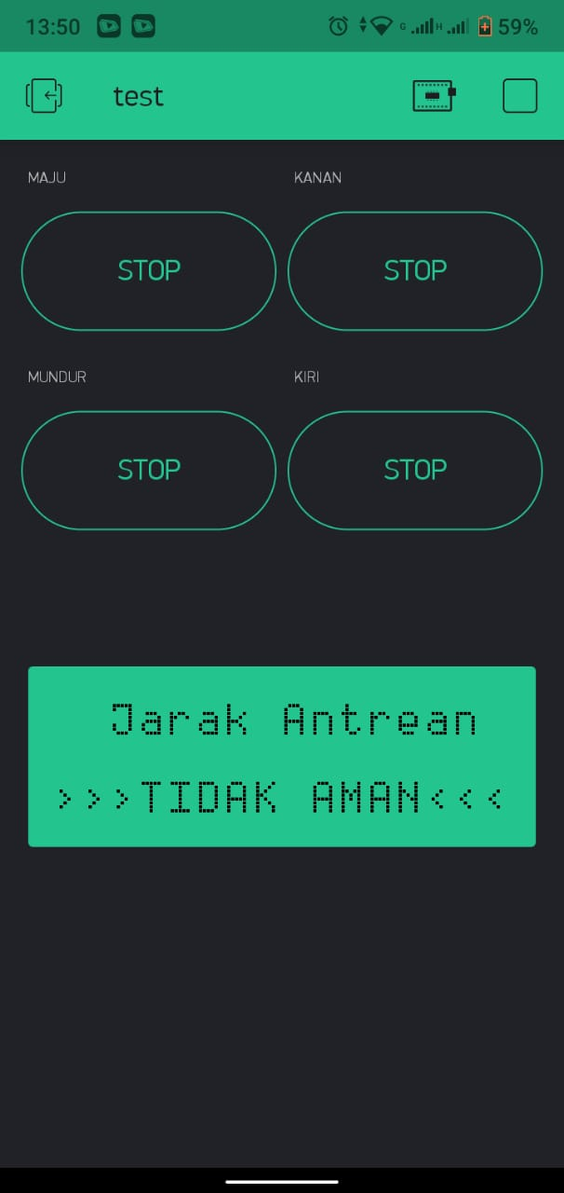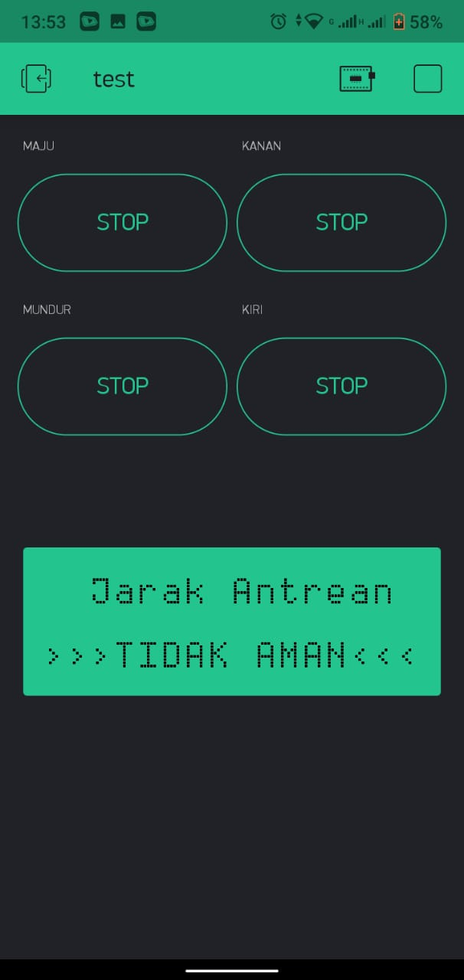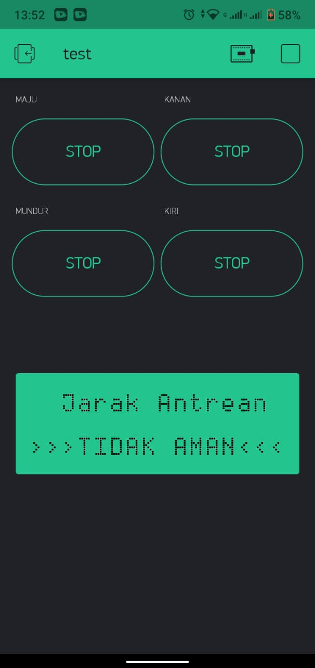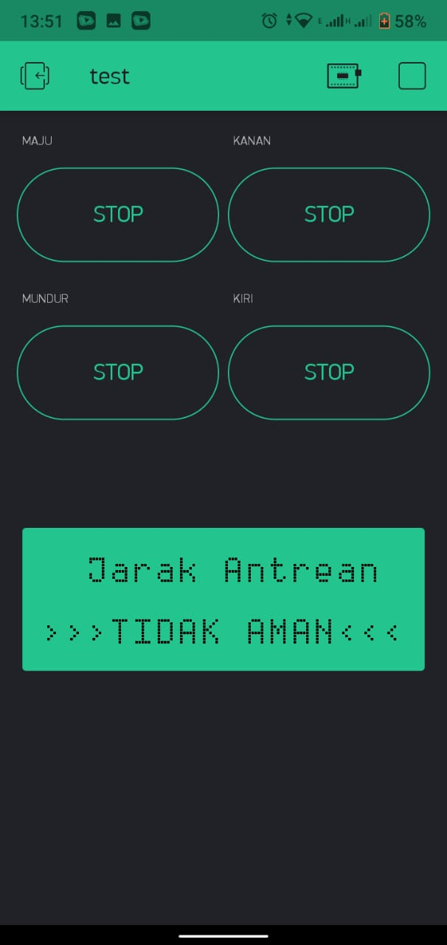

Perancangan Robot Sadetec menggunakan pada Software SketchUp

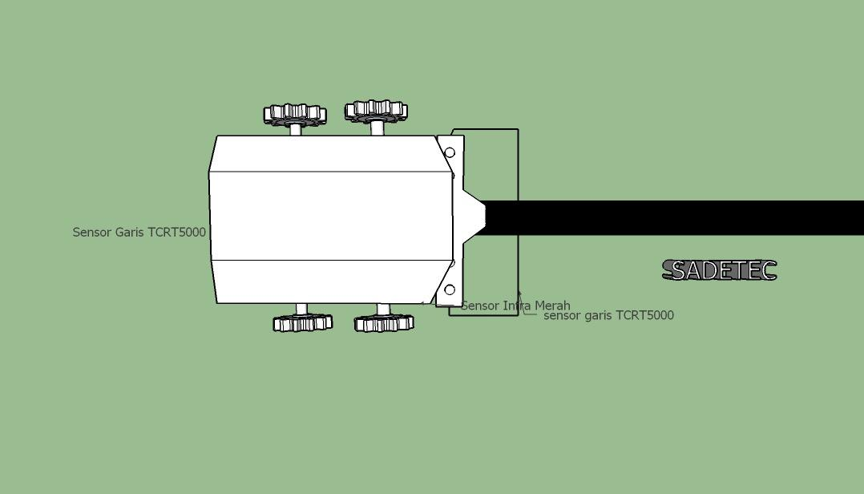

Gambar 10 Tampak Atas

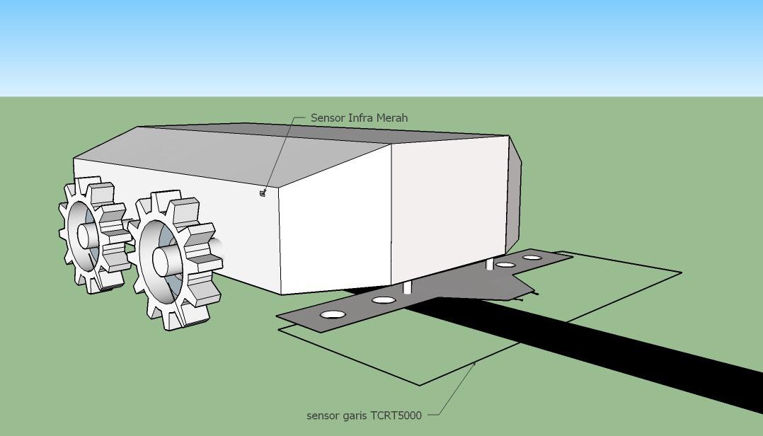

Gambar 11 Tampak Depan

Implementasi Robot Sadetec berbasisi Internet of Things

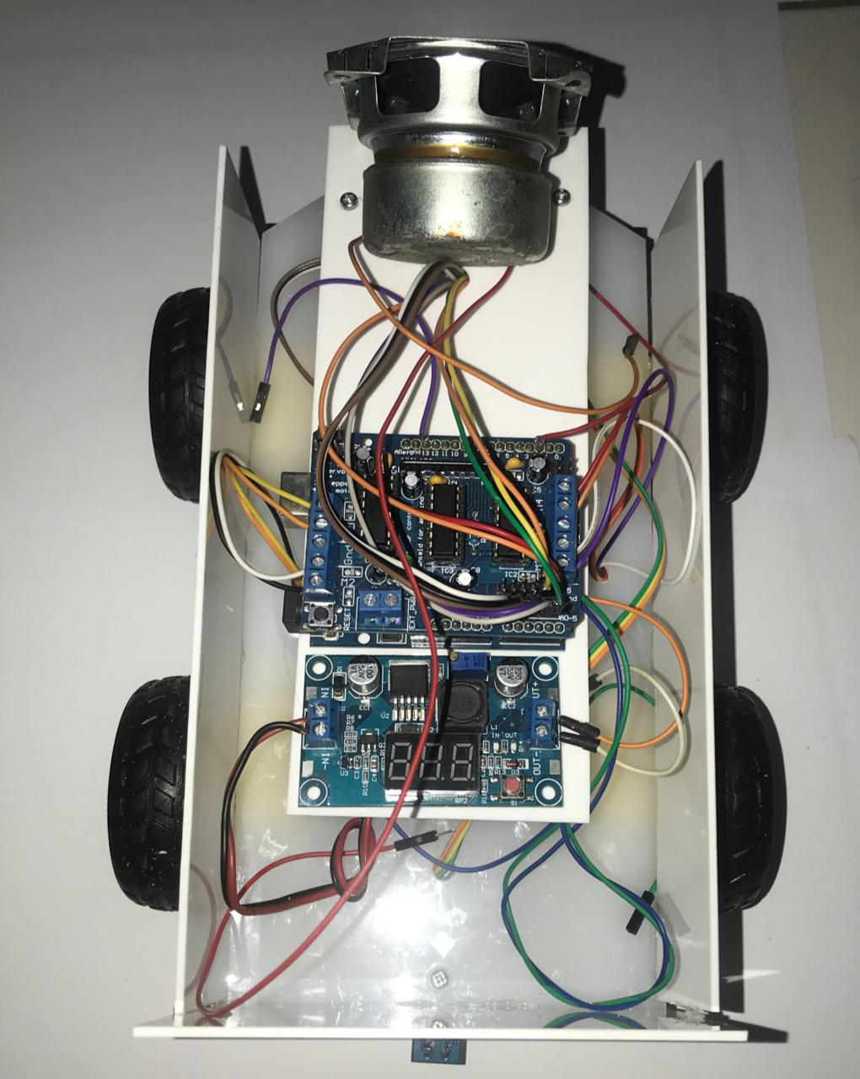

Gambar 11 Tampak Atas

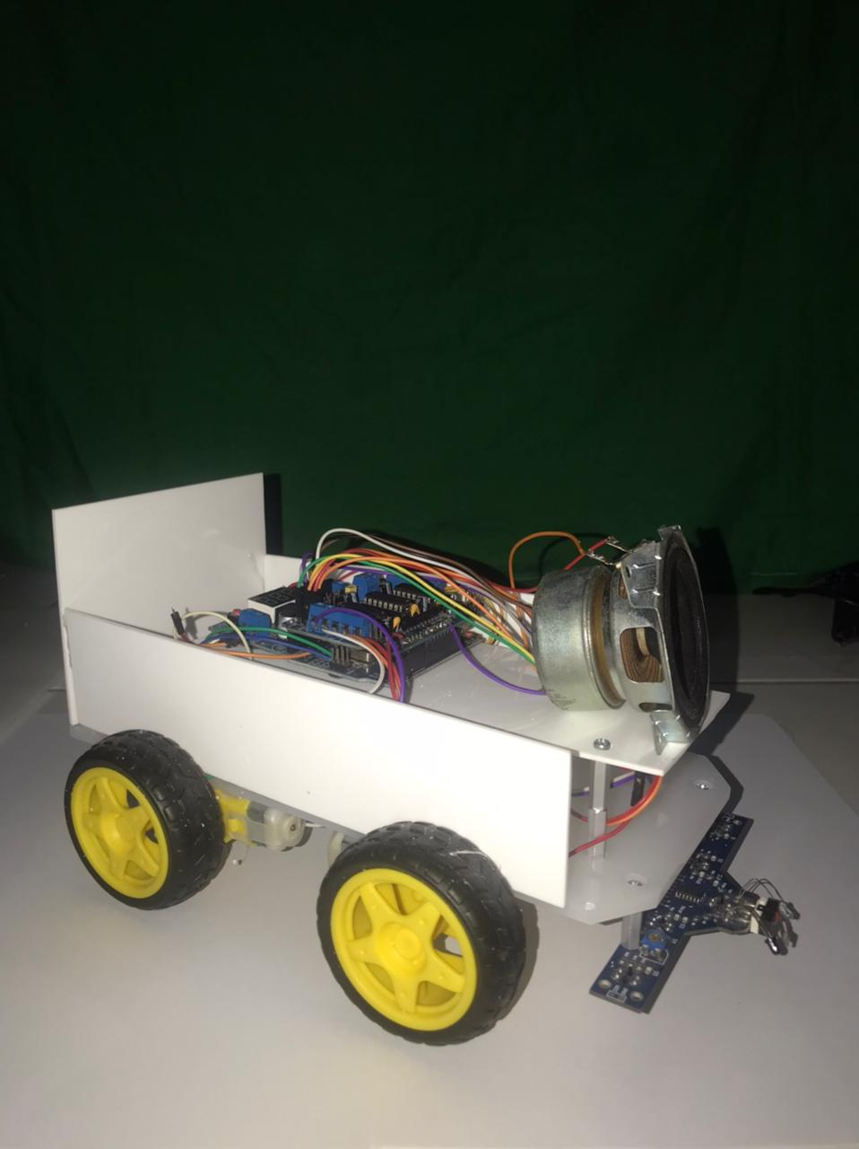

Gambar 13 Tampak Depan

Data hasil Pengujian Sensor Infrared

