Analysis of the Power Output and Efficiency of a 100-Wp Photovoltaic Module with Varying Glass Reflector Inclinations

Inrawan^{1,*,a}, Mahmuddin ^{1,b}, Faisal Habib ^{1,c,}, and Ahmed Saeed AlGhamdi ^{2,d}

¹ Department of Mechanical Engineering, Universitas Muslim Indonesia, Urip Sumoharjo 5, Makassar 90231, Indonesia
² Department of Electrical and Computer Engineering, Taif University, Al Hawiyah, Ta'if, 26523, Saudi Arabia

^{*,a} inrawaninra24@gmail.com , ^{b} mahmuddin@umi.ac.id , ^{c} faizal.habib@umi.ac.id , ^{d} asjannah@tu.edu.sa

Article Info  Keywords: Photovoltaic module; Glass reflector; Reflector inclination; Power output; Conversion efficiency  Received : 27 07 2026  Revised form : 08 09 2026  Accepted : 20 10 2026  Published : 30 10 2026 | Abstract  Flat glass reflectors offer a simple method for increasing the solar irradiance received by a photovoltaic (PV) module. However, reflector inclination may influence both electrical output and conversion efficiency. This study investigated the power output and efficiency of a 100-Wp PV module fitted with two flat glass reflectors at inclination angles of 15°, 30°, and 45°. An identical 100-Wp module without reflectors was used as the reference. Outdoor measurements were conducted at the Mechanical Engineering Laboratory, Universitas Muslim Indonesia, Makassar, from 8 to 10 February 2026. Each reflector angle was evaluated on a separate day, with solar irradiance, voltage, current, and output power recorded at 10:00, 12:00, and 14:00 local time. Incident solar power and conversion efficiency were calculated independently for both modules using the measured irradiance and a module area of 0.6901 m². The reflector-assisted module produced higher output power at all nine measurement points, with increases ranging from 2.89% to 20.86%. The maximum output power was 76.1 W at a reflector inclination of 15° and 12:00 local time, compared with 71.0 W for the reference module. At the same observation point, the corrected efficiency of the reflector-assisted module was 10.76%, while the reference module reached 11.16%. The findings indicate that the glass reflectors consistently increased the power output of the photovoltaic module, although their effect on conversion efficiency varied with reflector inclination, observation time, and incident irradiance. Among the tested configurations, the 15° reflector inclination produced the highest output power and the highest corrected efficiency of the reflector-assisted module.

Introduction
Photovoltaic (PV) technology converts solar radiation directly into electrical energy without fuel consumption or direct emissions during operation. However, the electrical performance of a PV module depends strongly on its operating environment. Solar irradiance, module temperature, installation geometry, and local weather conditions affect the voltage, current, power output, and conversion efficiency of the module. Higher solar irradiance generally increases the generated current and power, whereas an excessive rise in module temperature can reduce the operating voltage and overall efficiency [1], [2]. Various approaches have therefore been developed to increase the amount of useful solar radiation received by the PV surface. Concentrating photovoltaic systems, for example, use optical devices such as mirrors, lenses, and reflectors to redirect or concentrate incoming radiation onto the active area of a module [3]. Nevertheless, the performance of an enhancement method should not be judged solely from its maximum power gain. Its effect on power effectiveness, operating conditions, and module service life should also be considered [4].
The use of an external reflector is a relatively simple passive method for increasing the solar radiation incident on a PV module. A reflector redirects radiation that would otherwise fall outside the active surface toward the module. The additional radiation can increase the photocurrent and, under suitable operating conditions, improve electrical power generation. Kim et al. found that reflector geometry and adjustment influence the amount of radiation received by a PV panel and its resulting electricity production [5]. Agrawal et al. reported through three-dimensional opto-thermal analysis that mirror integration could increase the irradiance and power output of a PV module, although the additional absorbed radiation also raised the module temperature [6]. Their later investigation showed that the relative orientation of the module, reflector, and sun is a major factor in determining the performance gain [7].
Experimental work by Karimzadeh Kolamroudi et al. further showed that reflecting mirrors could increase the current and output power of a low-concentration PV system [8]. Their subsequent review identified reflector geometry, number, optical properties, orientation, and thermal management as important parameters in low-concentration PV applications [9]. Reflector shape also affects the way radiation is distributed over the module surface. Flat, parabolic, quadrangular, and combined reflector arrangements can produce different optical gains and temperature distributions, leading to different electrical responses [10]. These studies confirm that the addition of a reflector alone does not guarantee the same level of improvement under every condition. Its performance depends on how effectively the reflected radiation reaches the active PV surface.
Recent investigations have examined the effects of reflector dimensions, materials, height, and inclination more closely. Zabihi et al. experimentally reported that mirrors increased both the radiation received by PV modules and their electrical power output. However, the mirrors had to be positioned correctly to ensure that the reflected radiation reached the intended surface [11]. Moltames et al. showed through mathematical modelling that mirror height alters the reflection geometry and affects the irradiance distribution, module temperature, and electrical output [12]. Ardiyanto et al. also emphasized that reflector configuration, inclination, number, and material determine the additional solar radiation received by a PV panel [13].
Although conducted on bifacial modules, the parametric analysis by Borea et al. demonstrated that tilt selection cannot be separated from environmental and optical conditions when evaluating incident irradiance and energy yield [14]. Bintang et al. similarly reported that flat-mirror reflectors mounted on both sides of a PV module produced a higher average output than the corresponding configuration without reflectors [15]. Taken together, these findings show that reflector inclination is a primary design variable rather than a minor installation detail. It controls the direction and coverage of the reflected radiation and therefore influences the electrical response of the module.
An increase in incident radiation may also introduce a thermal penalty. Only part of the absorbed solar energy is converted into electricity, while the remaining energy contributes to module heating. For this reason, several studies have combined reflectors with cooling systems. Janna and Widodo reported that water cooling improved the electrical characteristics of a PV module by lowering its operating temperature [16]. Elbreki et al. evaluated a planar reflector combined with passive fins and showed that thermal management was necessary to maintain the performance of the reflector-assisted module [17]. Ismail et al. integrated parabolic bi-reflectors with a heat exchanger in a PV/T system and found that the reflector and cooling arrangement influenced voltage, current, output power, and efficiency [18].
Other studies have used phase-change materials or metal fins to control the additional heat generated by reflected radiation. Lotfi et al. reported that a reflector increased the solar energy received by a PV module, while phase-change material helped limit the corresponding temperature rise [19]. Firoozzadeh et al. combined mirrors and metal fins to improve electrical production while controlling module temperature [20]. PraveenKumar et al. also investigated aluminium reflectors integrated with passive cooling and phase-change material, confirming that optical enhancement and thermal management should be considered together [21]. These findings are important because an increase in irradiance does not necessarily produce a proportional increase in conversion efficiency when the module temperature also rises.
Studies conducted under Indonesian outdoor conditions provide further evidence that reflector performance depends on material, angle, and local operating conditions. Suryo et al. compared glass-mirror and aluminium-foil reflectors at different inclinations and reported that the power improvement varied with both reflector material and angle [22]. Hariyanto found that reflectors increased the radiation received by a solar panel but also noted that the associated temperature rise could reduce efficiency [23]. Putri et al. evaluated a 50-Wp PV system using reflector inclinations of 50°, 60°, and 70°. Under their experimental conditions, the highest reported efficiency occurred at an inclination of 70° [24]. These results indicate that a reflector angle producing favourable performance in one system cannot automatically be applied to another system with different module dimensions, reflector geometry, geographical location, solar position, and environmental conditions. Reflector material and optical characteristics may also affect module temperature and long-term operation, as shown in studies of spectrally selective reflectors [25].
The available literature has examined reflector-assisted PV systems through numerical modelling, laboratory testing, outdoor experiments, and combined reflector–cooling arrangements. However, the reported outcomes vary considerably because the studies used different module capacities, reflector materials, geometries, inclination ranges, cooling methods, locations, and measurement procedures [5]-[25]. Some studies focused on optical or numerical optimization, while others investigated reflectors together with cooling devices. Studies conducted in Indonesia have also used reflector angles and module capacities that differ from those considered in the present work [22]-[24]. Consequently, their reported optimum angles and performance gains cannot be transferred directly to a 100-Wp module equipped with flat glass reflectors.
A further issue is that maximum power output and maximum conversion efficiency may not occur at the same reflector inclination. Electrical power is influenced mainly by the measured voltage and current, while the calculated efficiency also depends on the incident solar power received by the module. Changes in irradiance and environmental conditions can therefore produce different trends in power and efficiency. A field comparison using a non-reflector module as a reference is required to clarify the electrical response obtained at each tested reflector inclination.
This study evaluates the power output and efficiency of a 100-Wp PV module equipped with two flat glass reflectors and compares its performance with a reference module without reflectors. Reflector inclinations of 15°, 30°, and 45° are examined under outdoor conditions at the Mechanical Engineering Laboratory of Universitas Muslim Indonesia, Makassar. Solar irradiance, voltage, and current are measured on both modules, while output power and conversion efficiency are determined from the experimental data.
The novelty of this study lies in three specific aspects that distinguish it from the reflector-assisted PV investigations reviewed above. First, each glass-reflector inclination is evaluated against a reference module without reflectors that is measured at the same observation times and under the same daily sky conditions, so that every reported gain originates from a paired field comparison rather than from a nominal module rating or a baseline recorded on a different occasion. Second, the solar irradiance is measured separately on the reflector-assisted module and on the reference module, and the incident solar power of each configuration is consequently recalculated from its own measured irradiance rather than from a single irradiance value applied to both modules. This treatment is essential because the reflector raises the radiation reaching the treatment module, and applying a common incident power to both configurations would overstate the efficiency of the reflector-assisted module. Third, the study separates the power response from the efficiency response and shows that the inclination yielding the highest output power is not necessarily the inclination yielding the highest conversion efficiency, since the additional reflected radiation increases both the electrical output and the incident power used in the efficiency calculation. Together, these three aspects provide field evidence that a reflector angle reported as favourable for one photovoltaic system cannot be transferred directly to another without re-examination under its own operating conditions. Accordingly, the objective of this study is to analyze the influence of glass-reflector inclination on PV power output and conversion efficiency, and to determine the performance differences between the reflector-assisted and the conventional configurations under identical daily test conditions.

Research Methodology

2.1. Method
This study employed an outdoor comparative experimental method to evaluate the effects of glass-reflector inclination on the power output and efficiency of a 100-Wp photovoltaic module. The experimental setup was installed at the Energy Conversion Engineering Laboratory, Department of Mechanical Engineering, Faculty of Engineering, Universitas Muslim Indonesia, Makassar. Measurements were conducted in an open area on the fifth floor of the laboratory building to provide direct solar exposure without obstruction from surrounding objects. 6
The experiment used two photovoltaic modules with the same nominal capacity of 100 Wp. One module was used as the reference configuration without reflectors, while the other was used as the treatment configuration and equipped with two flat glass reflectors mounted along both sides of the module. Each reflector measured 1120 mm × 300 mm. A digital protractor was used to set the reflector inclination at 15°, 30°, and 45°. Only the treatment module was equipped with reflectors, while the reference module remained without reflectors throughout the experiment.
Figure 1 shows the two experimental configurations used in the study. The treatment module was equipped with two flat glass reflectors, whereas the reference module was operated without reflectors.
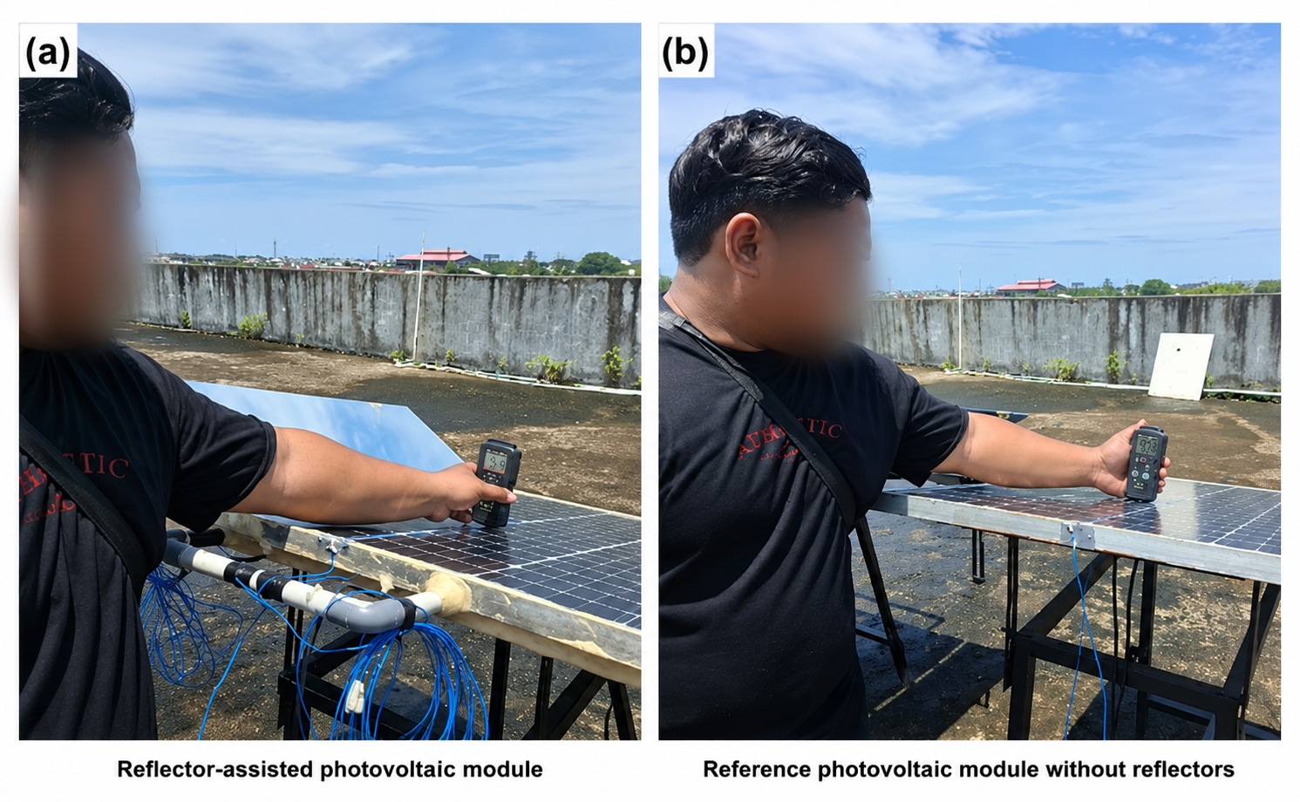
FIGURE 1. Experimental configurations: (a) reflector-assisted photovoltaic module and
(b) reference photovoltaic module without reflectors
The outdoor measurements were conducted over three consecutive days from 8 to 10 February 2026. A single reflector inclination was evaluated on each testing day: 15° on the first day, 30° on the second day, and 45° on the third day. Measurements were taken at 10:00, 12:00, and 14:00 Central Indonesia Time (Local Time). At each observation time, data were collected from both the reference and reflector-assisted modules. Therefore, the performance of the treatment module at each reflector inclination was compared with that of the reference module measured on the same day.
Solar irradiance at the module surface was measured using a solar power meter and expressed in W/m². The output voltage, current, and electrical power were measured at the DC output of each photovoltaic module before the solar charge controller. A voltmeter, ammeter, and DC wattmeter were used to record the electrical parameters. The measured variables were solar irradiance, maximum operating voltage, maximum operating current, and output power, while the calculated variables were incident solar power and photovoltaic conversion efficiency.
As shown in Figure 2, voltage, current, and output power were measured at the DC output of each photovoltaic module before the solar charge controller.
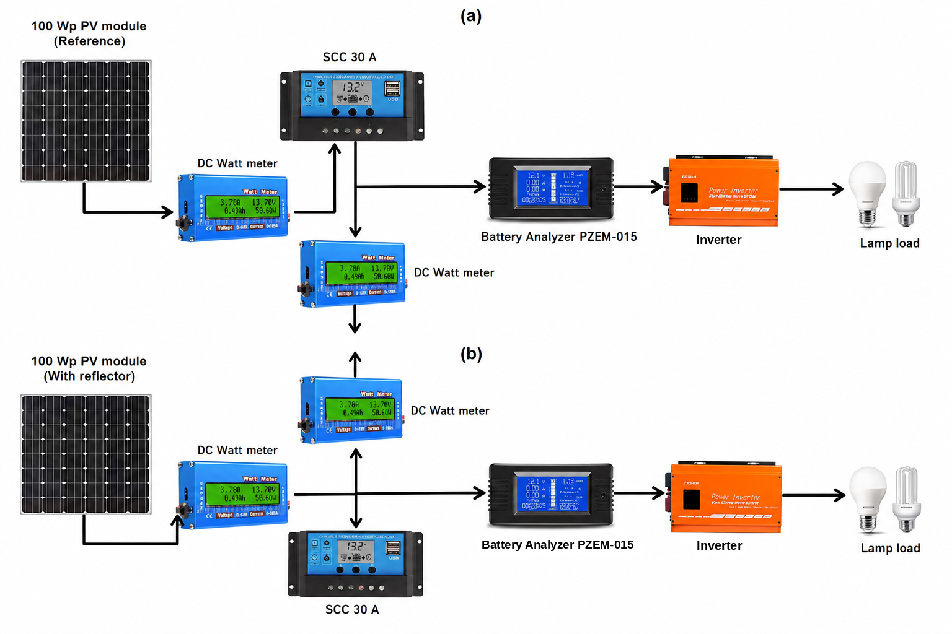
FIGURE 2. Measurement arrangement for (a) the reference photovoltaic module and
(b) the reflector-assisted photovoltaic module.

The principal experimental components and their functions are summarized in Table 1. Only equipment directly related to the reported measurements is included. Equipment associated with water cooling, flow-rate measurement, temperature sensing, or automated tracking is not included because those variables were not reported in the final experimental results of this work.

TABLE 1. Principal Components of the Experimental Setup
Component | Quantity | Specification or function
Photovoltaic module | 2 units | Nominal capacity of 100 Wp per module
Flat glass reflector | 2 sheets | Dimensions of 1120 mm × 300 mm; mounted on both sides of the treatment module
Solar power meter | 1 unit | Measurement of solar irradiance at the PV module surface
Digital protractor | 1 unit | Adjustment of reflector inclinations at 15°, 30°, and 45°
Voltmeter | 1 unit | Measurement of PV output voltage
Ammeter | 1 unit | Measurement of PV output current
DC wattmeter | 1 unit | Measurement of PV output power
Solar charge controller | 1 unit | Regulation of the electrical output after the measurement point
Computer or laptop | 1 unit | Data storage and processing

The incident solar power received by the photovoltaic module was calculated as

$$\begin{matrix} & P_{in}=GA & & \text{(1)}\end{matrix}$$where $P_{in }$is the incident solar power in W, $G$is the measured solar irradiance in W/m², and $A$is the surface area of the photovoltaic module in m². The calculations in this work used a module area of 0.6901 m².
The photovoltaic conversion efficiency was determined using
$$\begin{matrix} & η=\frac{P_{out}}{P_{in}}×100\% & & \text{(2)}\end{matrix}$$
where $η$is the module efficiency in %, $P_{out}$is the measured DC output power in W, and $P_{in}$is the incident solar power calculated using (1).
The measured and calculated values were arranged according to reflector inclination and observation time. The performance of the reflector-assisted module was then compared with that of the reference module in terms of solar irradiance, voltage, current, output power, and efficiency. The comparison was used to identify the electrical response associated with each of the three reflector inclinations tested in this study. Since the three angles were evaluated on different days, the comparison between angles was interpreted together with the irradiance measured on each testing day rather than assuming identical weather conditions.
The experimental schedule and reflector-angle arrangement are presented in Table 2. Each reflector inclination was tested on one day, while measurements were taken at the same three observation times.
TABLE 2. Experimental Test Matrix
Testing day | Date | Reflector inclination | Observation times
1 | 8 February 2026 | 15° | 10:00, 12:00, and 14:00 Local Time
2 | 9 February 2026 | 30° | 10:00, 12:00, and 14:00 Local Time
3 | 10 February 2026 | 45° | 10:00, 12:00, and 14:00 Local Time
Figure 3 summarizes the experimental procedure, beginning with equipment preparation and ending with the comparison of the reference and reflector-assisted photovoltaic modules.

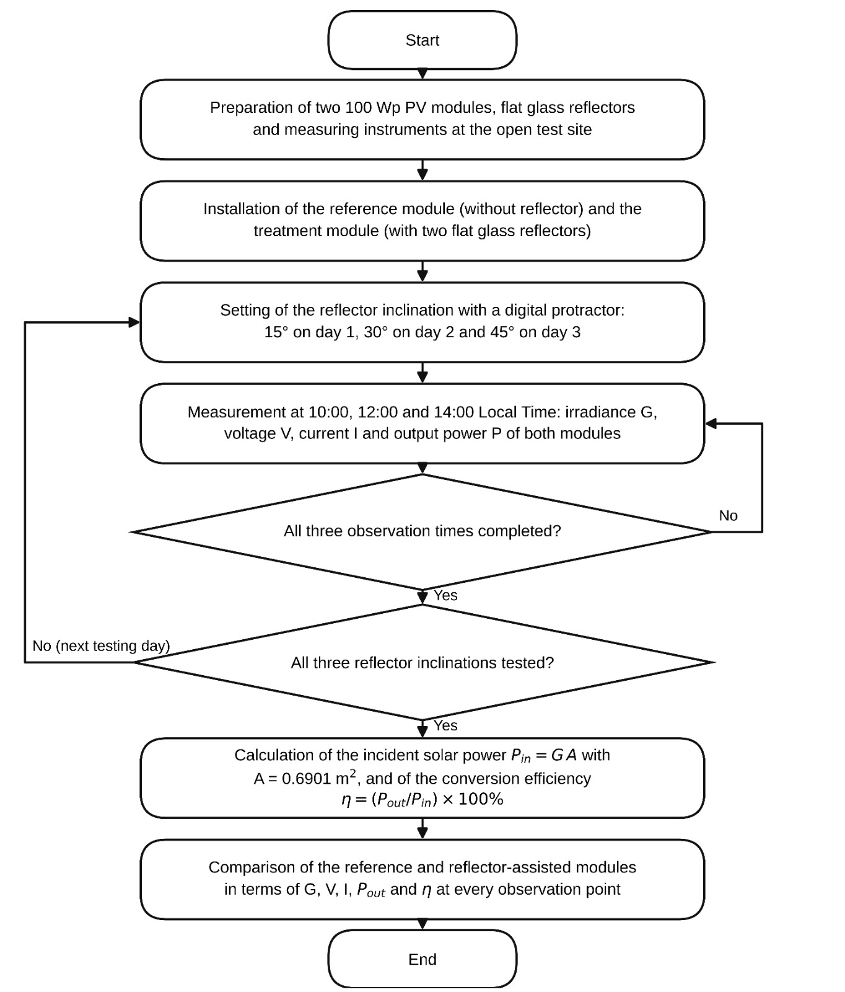
FIGURE 3. Flowchart of the experimental and data-analysis procedures

Results and Discussion
The experimental results were evaluated using the irradiance, voltage, current, and output-power measurements obtained from the reference and reflector-assisted photovoltaic modules. Each reflector inclination was tested on a different day; therefore, the primary comparison was made between the two module configurations measured at the same time and under the same daily test condition. Cross-angle comparisons were interpreted together with the corresponding irradiance levels.

3.1. Solar Irradiance and Measured Electrical Performance
Table 3 presents the measured irradiance and electrical performance of the reference and reflector-assisted modules. The test conditions corresponded to reflector inclinations of 15°, 30°, and 45°, with measurements taken at 10:00, 12:00, and 14:00 local time.
The measured irradiance followed a similar daily pattern during all three test days. The highest values occurred at 12:00 local time, while lower values were recorded at 10:00 and 14:00 local time. For the reflector-assisted module, the maximum irradiance was 1157 W/m² under the 45° test condition at 12:00 local time. The corresponding reference-module irradiance was 1103 W/m².

TABLE 3. Measured Irradiance and Electrical Performance of The Photovoltaic Modules
Reflector inclination | Time (Local Time) | $G_{ref}$ (W/m²) | $G_{refl}$ (W/m²) | $V_{ref}$ (V) | $V_{refl}$ (V) | $I_{ref}$ (A) | $I_{refl}$ (A) | $P_{out,ref}$ (W) | $P_{out,refl}$ (W)
15° | 10:00 | 328 | 330 | 12.75 | 12.77 | 1.58 | 1.77 | 18.7 | 22.6
15° | 12:00 | 922 | 1025 | 13.34 | 13.39 | 5.32 | 5.68 | 71.0 | 76.1
15° | 14:00 | 254 | 278 | 12.73 | 12.77 | 1.24 | 1.34 | 15.8 | 17.2
30° | 10:00 | 474 | 490 | 13.02 | 13.02 | 2.40 | 2.53 | 31.2 | 32.9
30° | 12:00 | 1020 | 1148 | 13.27 | 13.35 | 5.50 | 5.50 | 65.8 | 67.7
30° | 14:00 | 278 | 295 | 12.77 | 12.78 | 1.37 | 1.53 | 17.5 | 19.6
45° | 10:00 | 488 | 530 | 12.98 | 12.98 | 2.55 | 2.68 | 33.1 | 34.8
45° | 12:00 | 1103 | 1157 | 13.28 | 13.37 | 5.04 | 5.55 | 66.9 | 74.3
45° | 14:00 | 300.3 | 311 | 12.77 | 12.80 | 1.47 | 1.61 | 18.8 | 20.6

At every observation point, the irradiance measured on the reflector-assisted module was higher than that measured on the reference module. The relative increase ranged from 0.61% at the 15° condition at 10:00 local time to 12.55% at the 30° condition at 12:00 local time. This result indicates that the flat glass reflectors redirected additional solar radiation toward the module surface. Similar increases in received irradiance have been reported for PV systems using external mirrors and properly adjusted reflector orientations [5]–[8], [11], [15].
The irradiance differences between the three testing days also show that the reflector angles were not evaluated under identical environmental conditions. For this reason, the measured performance at one inclination should not be compared directly with another inclination without considering the irradiance recorded during each test. The most reliable comparison is between the reference and reflector-assisted modules tested simultaneously on the same day.

3.2. Voltage and Current Response
The voltage response was relatively stable across the tested configurations. The recorded voltages ranged from 12.73 to 13.34 V for the reference module and from 12.77 to 13.39 V for the reflector-assisted module. The largest voltage difference between the two configurations was only 0.09 V, recorded under the 45° test condition at 12:00 local time. In relative terms, the voltage increase did not exceed 0.68%.
The current response was more sensitive to the additional irradiance. The reflector-assisted module produced a higher current at eight of the nine observation points. The only condition without an increase was the 30° test at 12:00 local time, when both modules recorded 5.50 A. The relative current increase ranged from 5.10% to 12.03% at the observation points where an increase occurred.
Under the 15° condition, the reflector-assisted module produced currents of 1.77, 5.68, and 1.34 A, compared with 1.58, 5.32, and 1.24 A for the reference module. Under the 30° condition, the current increases were more moderate at 10:00 and 12:00 local time, while a larger increase was recorded at 14:00 local time. Under the 45° condition, the reflector-assisted module produced higher currents at all observation times, including 5.55 A at 12:00 local time compared with 5.04 A for the reference module.
These results show that the increase in module output was associated mainly with the current response rather than a substantial voltage change. This behavior is consistent with the increased irradiance received by the reflector-assisted module. Previous reflector-assisted PV studies have likewise reported that the additional radiation supplied by mirrors primarily increases photocurrent and consequently raises electrical output [6]–[8], [11].
The output-power values in Table 3 are reported directly from the DC wattmeter measurements. They were not recalculated from the displayed voltage and current values because the recorded voltage and current values were rounded and represented separate instrument readings.

3.3. Output Power Improvement
The reflector-assisted module produced higher output power than the reference module at all nine observation points. Under the 15° test condition, the reflector-assisted output powers were 22.6, 76.1, and 17.2 W at 10:00, 12:00, and 14:00 local time, respectively. The corresponding values for the reference module were 18.7, 71.0, and 15.8 W. These differences represented power increases of 20.86%, 7.18%, and 8.86%.
Under the 30° test condition, the output-power increases were 5.45% at 10:00 local time, 2.89% at 12:00 local time, and 12.00% at 14:00 local time. Under the 45° condition, the increases were 5.14%, 11.06%, and 9.57%, respectively.
The largest relative power improvement was 20.86%, recorded at the 15° condition at 10:00 local time. The highest absolute output power was also recorded under the 15° condition, reaching 76.1 W at 12:00 local time, compared with 71.0 W for the reference module. The 45° condition produced the second-highest reflector-assisted output of 74.3 W at 12:00 local time.
These results confirm that the addition of the glass reflectors increased the electrical power generated by the module throughout the tested periods. The magnitude of the increase, however, varied with observation time and reflector inclination. This variation is expected because the reflector angle determines the direction and coverage of the reflected radiation on the PV surface [5], [7], [11]–[13].
The power results are consistent with earlier investigations in which flat or external reflectors increased PV output compared with non-reflector configurations [8], [11], [15]. Studies conducted under Indonesian outdoor conditions have also shown that the amount of improvement depends on reflector angle, material, module geometry, and local solar conditions [22]–[24].

3.4. Recalculated Incident Power and Conversion Efficiency
During data verification, the incident power and conversion efficiency were recalculated using the irradiance measured separately for the reference and reflector-assisted modules. This correction was necessary because the two configurations received different irradiance levels, whereas the initial calculation applied the same incident power to both modules. The photovoltaic module area was determined from its dimensions of 1.03 m × 0.67 m, resulting in a geometric area of 0.6901 m².

The incident solar power for each configuration was calculated as

$$\begin{matrix} & P_{in,ref}=G_{ref}A & & \text{(3)}\end{matrix}$$
and
$$\begin{matrix} & P_{in,refl}=G_{refl}A & & \text{(4)}\end{matrix}$$

where $G_{ref}$and $G_{refl}$are the measured irradiance values for the reference and reflector-assisted modules, respectively, and $A$is the module area. The conversion efficiency of each module was then calculated as

$$\begin{matrix} & η_{ref}=\frac{P_{out,ref}}{P_{in,ref}}×100\% & & \text{(5)}\end{matrix}$$
and
$$\begin{matrix} & η_{refl}=\frac{P_{out,refl}}{P_{in,refl}}×100\%. & & \text{(6)}\end{matrix}$$
As an example, at a reflector inclination of 15° and 10:00 local time, the incident powers received by the reference and reflector-assisted modules were calculated as

$$P_{in,ref}=328×0.6901=226.35\text{ W}$$
and
$$P_{in,refl}=330×0.6901=227.73\text{ W}.$$
The corresponding efficiencies were

$$η_{ref}=\frac{18.7}{226.35}×100\%=8.26\%$$
and
$$η_{refl}=\frac{22.6}{227.73}×100\%=9.92\%.$$
The incident solar power and conversion efficiency were recalculated using the irradiance measured separately for each module. The geometric area of the PV module was $0.6901 m^{2}$. The corrected results are presented in Table 4.

TABLE 4. Recalculated Incident Power and Photovoltaic Conversion Efficiency
Reflector inclination | Time (Local Time) | $P_{in,ref}$(W) | $η_{ref}$(%) | $P_{in,refl}$(W) | $η_{refl}$(%)
15° | 10:00 | 226.35 | 8.26 | 227.73 | 9.92
15° | 12:00 | 636.27 | 11.16 | 707.35 | 10.76
15° | 14:00 | 175.29 | 9.01 | 191.85 | 8.97
30° | 10:00 | 327.11 | 9.54 | 338.15 | 9.73
30° | 12:00 | 703.90 | 9.35 | 792.23 | 8.55
30° | 14:00 | 191.85 | 9.12 | 203.58 | 9.63
45° | 10:00 | 336.77 | 9.83 | 365.75 | 9.51
45° | 12:00 | 761.18 | 8.79 | 798.45 | 9.31
45° | 14:00 | 207.24 | 9.07 | 214.62 | 9.60

The recalculated efficiencies of the two configurations are compared in Figure 4. The three panels correspond to the daily test conditions in which the reflector inclinations were set at 15°, 30°, and 45°. Since each inclination was tested on a different day, the comparison should be interpreted between the reference and reflector-assisted modules within each panel.

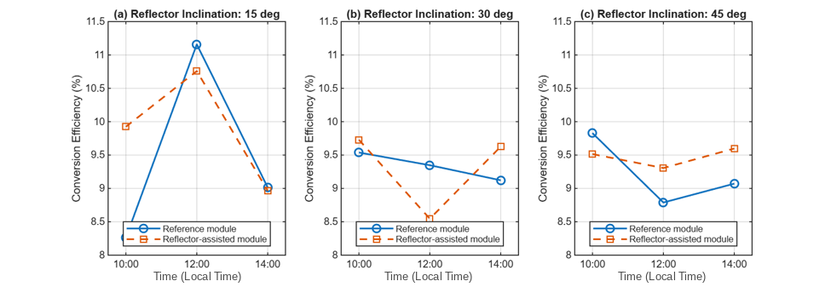
FIGURE 4. Corrected conversion efficiencies of the reference and reflector-assisted photovoltaic modules under test conditions corresponding to reflector inclinations of (a) 15°, (b) 30°, and (c) 45°

As shown in Figure 4(a), the reflector-assisted module achieved a higher efficiency than the reference module at 10:00 local time under the 15° test condition. The efficiencies were 9.92% and 8.26%, respectively, corresponding to a difference of 1.66 percentage points. At 12:00 local time, however, the reference module reached 11.16%, while the reflector-assisted module recorded 10.76%. At 14:00 local time, the efficiencies were nearly identical, at 9.01% for the reference module and 8.97% for the reflector-assisted module.
Under the 30° test condition, Figure 4(b) shows that the reflector-assisted module produced slightly higher efficiencies at 10:00 and 14:00 local time. The corresponding values were 9.73% and 9.63%, compared with 9.54% and 9.12% for the reference module. At 12:00 local time, the reflector-assisted efficiency decreased to 8.55%, while the reference module reached 9.35%.
Figure 4(c) presents the efficiency results under the 45° test condition. At 10:00 local time, the reflector-assisted module recorded 9.51%, which was lower than the 9.83% obtained by the reference module. At 12:00 and 14:00 local time, the reflector-assisted configuration achieved efficiencies of 9.31% and 9.60%, respectively, compared with 8.79% and 9.07% for the reference configuration.
The highest corrected efficiency of the reflector-assisted module was 10.76%, recorded under the 15° test condition at 12:00 local time. However, the reference module achieved a slightly higher efficiency of 11.16% under the same test condition. These results demonstrate that higher output power did not always correspond to higher conversion efficiency. The reflector-assisted module received more incident solar power, which increased both its electrical output and the denominator used in the efficiency calculation.
The reflector therefore had a consistent positive effect on output power, but its effect on conversion efficiency varied with the reflector inclination, observation time, and measured irradiance. The different efficiency trends are consistent with previous studies showing that the most favorable reflector angle is system- and condition-dependent rather than universal [22]–[24].

3.5. Effect of Reflector Inclination on Overall Performance
The three tested inclinations produced different electrical responses. Under the 15° condition, the reflector-assisted module generated the highest measured output power of 76.1 W and the highest corrected reflector-assisted efficiency of 10.76%, both at 12:00 local time. The same condition also produced the largest relative power increase, 20.86%, at 10:00 local time.
The 30° condition produced lower power gains at 10:00 and 12:00 local time but generated a 12.00% increase at 14:00 local time. Its efficiency response was mixed, with higher reflector-assisted efficiency at 10:00 and 14:00 local time but lower efficiency at 12:00 local time.
Under the 45° condition, the reflector-assisted module produced higher output power at all observation times and higher efficiency at 12:00 and 14:00 local time. Its maximum output power was 74.3 W, which was lower than the maximum of 76.1 W recorded under the 15° condition.
Based on the measured results, no single inclination produced the greatest improvement for every performance indicator and observation time. The 15° condition produced the highest absolute power and corrected reflector-assisted efficiency, whereas the 45° condition provided higher efficiency than the reference module during the noon and afternoon measurements. Therefore, the tested inclinations should be evaluated using irradiance, power output, and conversion efficiency together rather than selecting an angle solely from one parameter.
The present experiment was conducted using one testing day for each reflector inclination and three observation times per day. Consequently, differences among the 15°, 30°, and 45° conditions also include variations in daily irradiance. The results support direct comparisons between the reference and reflector-assisted configurations tested simultaneously, but they are not sufficient to establish a universal optimum reflector angle.
Module temperature was not included in the final measurement data. Although previous studies have reported that additional reflected irradiance may increase module temperature and influence efficiency [6], [23], the efficiency variations observed in this study cannot be attributed quantitatively to temperature. The discussion is therefore limited to the measured irradiance and electrical parameters.

3.6. Main Findings
The experimental results can be summarized as follows. First, the flat glass reflectors increased the measured irradiance at every observation point, with relative increases ranging from 0.61% to 12.55%. Second, the voltage response changed only slightly, while the current generally increased with the additional irradiance. Third, the reflector-assisted module produced higher output power than the reference module at all nine observation points, with output-power improvements ranging from 2.89% to 20.86%. The highest output power was 76.1 W under the 15° test condition at 12:00 local time, and the highest corrected reflector-assisted efficiency was 10.76%, also under the 15° condition at 12:00 local time. Finally, the reflector did not increase conversion efficiency consistently at every observation point.

Conclusion
This study evaluated the effect of flat glass-reflector inclination on the power output and conversion efficiency of a 100-Wp photovoltaic module. The reflector-assisted module produced higher output power than the reference module at all nine observation points, with improvements ranging from 2.89% to 20.86%. The highest output power was 76.1 W at a reflector inclination of 15° and 12:00 local time, compared with 71.0 W for the reference module under the same observation condition.
The influence of the reflectors on conversion efficiency was not uniform. After the incident solar power was recalculated using the irradiance measured separately for each module, the highest corrected efficiency of the reflector-assisted module was 10.76%, recorded at the 15° condition and 12:00 local time. At the same observation point, the reference module reached an efficiency of 11.16%. This result shows that the increase in output power was not always accompanied by a proportional increase in conversion efficiency because the reflector-assisted module also received higher incident solar power.
Among the three inclinations examined, the 15° reflector inclination produced the highest output power and the highest corrected efficiency of the reflector-assisted module. It can therefore be identified as the best-performing inclination under the present test conditions. However, the reflector angles were tested on different days with different irradiance levels, so the result should not be interpreted as establishing a universally optimum reflector angle.
Future studies should test each reflector inclination repeatedly over several days under comparable environmental conditions. Additional inclination angles, particularly around 15°, should also be examined to determine the most favorable operating range. Simultaneous measurement of module temperature, irradiance, voltage, current, and output power would provide a more complete explanation of the relationship between reflected solar radiation and photovoltaic conversion efficiency.

Acknowledgements
The authors would like to thank the Department of Mechanical Engineering, Faculty of Engineering, Universitas Muslim Indonesia, Makassar, for providing the laboratory facilities and measurement instruments used in this study. The authors also thank all parties who assisted during the outdoor data collection.

Data Availability Statement
The data that support the findings of this study are available from the corresponding author, [I.], upon reasonable request.

References
- L. M. Shaker, A. A. Al-Amiery, M. M. Hanoon, W. K. Al-Azzawi, and A. A. H. Kadhum, “Examining the influence of thermal effects on solar cells: A comprehensive review,” Sustain. Energy Res., vol. 11, 2024, doi: 10.1186/s40807-024-00100-8.
- M. Sharaf, M. S. Yousef, and A. S. Huzayyin, “Review of cooling techniques used to enhance the efficiency of photovoltaic power systems,” Environ. Sci. Pollut. Res., vol. 29, no. 18, pp. 26131–26159, 2022, doi: 10.1007/s11356-022-18719-9.
- H. Apostoleris, M. Stefancich, and M. Chiesa, “The CPV ‘Toolbox’: New approaches to maximizing solar resource utilization with application-oriented concentrator photovoltaics,” Energies, vol. 14, no. 4, 2021, doi: 10.3390/en14040795.
- S. M. Sultan, C. P. Tso, M. Z. Abdullah, and K. Sopian, “A new method for assessing the performance of photovoltaic module enhancing techniques based on the lifespan and power effectiveness factor,” Processes, vol. 13, no. 5, 2025, doi: 10.3390/pr13051311.
- M. K. Kim, K. O. Abdulkadir, J. Liu, J.-H. Choi, and H. Wen, “Optimal design strategy of a solar reflector combining photovoltaic panels to improve electricity output: A case study in Calgary, Canada,” Sustainability, vol. 13, no. 11, 2021, doi: 10.3390/su13116115.
- M. Agrawal, A. Kumar, and A. Chowdhury, “A detailed simulation-based study on the effect of mirror integration on PV module(s) with analysis of different wind flow scheme,” Sol. Energy, vol. 222, pp. 129–144, 2021, doi: 10.1016/j.solener.2021.05.028.
- M. Agrawal, P. Chhajed, and A. Chowdhury, “Performance analysis of photovoltaic module with reflector: Optimizing orientation with different tilt scenarios,” Renew. Energy, vol. 186, pp. 10–25, 2022, doi: 10.1016/j.renene.2021.12.149.
- M. Karimzadeh Kolamroudi, M. Ilkan, F. Egelioglu, and B. Safaei, “Maximization of the output power of low concentrating photovoltaic systems by the application of reflecting mirrors,” Renew. Energy, vol. 189, pp. 822–835, 2022, doi: 10.1016/j.renene.2022.03.031.
- M. Karimzadeh Kolamroudi, M. Ilkan, F. Egelioglu, and B. Safaei, “A comparative study of LCPV by mirror reflection against other systems: Recent techniques, implications, and performances,” Sol. Energy, vol. 250, pp. 70–90, 2023, doi: 10.1016/j.solener.2022.12.017.
- M. Asvad, M. Gorji, and A. Mahdavi, “Performance analysis of a solar module with different reflectors and cooling flow fields,” Appl. Therm. Eng., vol. 219, 2023, doi: 10.1016/j.applthermaleng.2022.119469.
- A. Zabihi, M. Parhamfar, S. S. S. R. Sarathbabu Duvvuri, and M. Abtahi, “Increase power output and radiation in photovoltaic systems by installing mirrors,” Meas. Sensors, vol. 31, 2024, doi: 10.1016/j.measen.2023.100946.
- R. Moltames, Y. Noorollahi, and H. Yousefi, “Mathematical modelling and technical analysis of an auxiliary system to reflect solar radiations for PV panels: Effect of mirror height on the system performance,” Sol. Energy Adv., vol. 4, 2024, doi: 10.1016/j.seja.2024.100069.
- E. D. Ardiyanto, Z. Arifin, R. A. Rachmanto, K. Basyar, and S. D. Prasetyo, “Amplification of solar radiation intensity on photovoltaic panel using reflectors to increase power output,” in Proceedings of the 9th International Conference and Exhibition on Sustainable Energy and Advanced Materials BT - Proceedings of the 9th International Conference and Exhibition on Sustainable Energy and Advanced Materials, Springer, 2024, pp. 285–295. doi: 10.1007/978-981-97-0106-3_46.
- R. A. Borea, V. Cirimele, F. Lo Franco, G. Maugeri, and F. Melino, “Impact of environmental variables on tilt selection for energy yield maximization in bifacial photovoltaic modules: Modeling review and parametric analysis,” Appl. Sci., vol. 14, no. 24, 2024, doi: 10.3390/app142411497.
- S. Bintang, M. A. R. Sembiring, D. H. Sinaga, M. S. Dewy, R. F. S. Tarigan, and P. R. Marpaung, “The effect of reflector application for solar panel output improvement,” J. Phys. Conf. Ser., vol. 2193, no. 1, 2022, doi: 10.1088/1742-6596/2193/1/012074.
- N. M. Janna and D. A. Widodo, “Analisis karakteristik modul panel surya dengan sistem pendingin air,” J. Fokus Elektroda Energi List. Telekomun. Komputer, Elektron. dan Kendali, vol. 6, no. 1, pp. 37–42, 2021, doi: 10.33772/jfe.v6i1.16200.
- A. M. Elbreki, A. F. Muftah, K. Sopian, H. Jarimi, A. Fazlizan, and A. Ibrahim, “Experimental and economic analysis of passive cooling PV module using fins and planar reflector,” Case Stud. Therm. Eng., vol. 23, 2021, doi: 10.1016/j.csite.2020.100801.
- B. Ismail, B. Mohammed, O. Abdelkhalek, and S. Elhadj, “An experimental study of PV/T system using parabolic reflectors and heat exchanger,” Indones. J. Electr. Eng. Comput. Sci., vol. 24, no. 3, pp. 1297–1306, 2021, doi: 10.11591/ijeecs.v24.i3.pp1297-1306.
- M. Lotfi, A. H. Shiravi, and M. Firoozzadeh, “Experimental study on simultaneous use of phase change material and reflector to enhance the performance of photovoltaic modules,” J. Energy Storage, vol. 54, 2022, doi: 10.1016/j.est.2022.105342.
- M. Firoozzadeh, M. Lotfi, and A. H. Shiravi, “An experimental study on simultaneous use of metal fins and mirror to improve the performance of photovoltaic panels,” Sustainability, vol. 14, no. 24, 2022, doi: 10.3390/su142416986.
- S. PraveenKumar, E. B. Agyekum, A. Kumar, and V. I. Velkin, “Performance evaluation with low-cost aluminum reflectors and phase change material integrated to solar PV modules using natural air convection: An experimental investigation,” Energy, vol. 266, 2023, doi: 10.1016/j.energy.2022.126415.
- T. H. Suryo, D. Rhakasywi, and Fahrudin, “The effect of solar panel output power analysis with reflector angle optimization and addition of heatsink-fan cooling system,” J. Appl. Sci. Eng. Technol. Educ., vol. 5, no. 1, pp. 93–122, 2023, doi: 10.35877/454RI.asci1535.
- S. Hariyanto, “Rancang bangun reflektor untuk mengoptimalkan daya serap matahari pada panel surya dengan variasi sudut guna menghasilkan daya optimal,” J. Ilm. Telsinas Elektro, Sipil dan Tek. Inf., vol. 4, no. 1, pp. 41–45, 2021, doi: 10.38043/telsinas.v4i1.2896.
- F. S. Putri, S. P. Mursid, and A. Daud, “Rancang bangun PLTS kapasitas 50 Wp menggunakan reflektor untuk meningkatkan efisiensi panel surya,” in Proceedings of the 13th Industrial Research Workshop and National Seminar BT - Proceedings of the 13th Industrial Research Workshop and National Seminar, 2022, pp. 304–309. doi: 10.35313/irwns.v13i01.4281.
- M. Agrawal and A. Chowdhury, “Reassessment of different flat TCO integrated reflectors for the crystalline silicon solar PV module in view of its longer operational life,” Prog. Photovoltaics Res. Appl., vol. 30, no. 11, pp. 1325–1342, 2022, doi: 10.1002/pip.3593.

